EEL 4930/5934 BioSignals Processing

Assignment 1- Due: September 11

Please write a report answering the following questions. Submit the report and all the m-files you used to answer the questions on Blackboard in Module Assignments / Assignment 1.

1. Write MATLAB code to
   1. Download, read and plot channel 1 only of the data file edbe0103.mat.
      1. What is the duration of the ECG signal in seconds? The duration is 7200 seconds
      2. How is the length of the ECG signal in samples?
      3. What is the sampling rate?
   2. Find an estimate of the heart rate by measuring the duration between consecutive R waves. Save them in a vector called TH. First element of TH should be the distance between the first and second R waves, the second element of TH should be the distance between the second and third R waves and so on.
   3. Plot TH versus the given time vector tm (discard the last point of tm so that TH and tm are the same length).
   4. Find the mean and variance of TH.
   5. Comment on any observations, difficulties or aberrations you encounter.

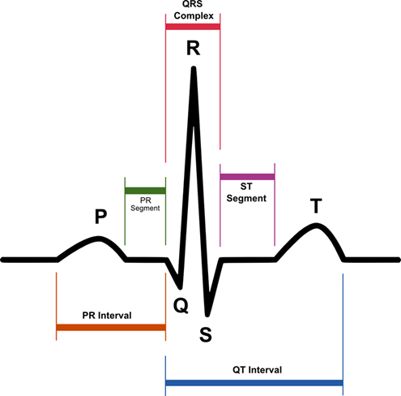

1. Please read
   1. the paper “Research on ECG Niometric in Cardiac Irregularity Conditions” by Wang and Zhang, Proceedings of the 2014 International Conference on Medical Biometrics.
   2. Study the code Assignment1NE3.m.
      1. Use the output xx of the correlation filter to redo question 1.b.
      2. At each peak, compute the correlation coefficient[1] to determine if a peak is part of a QRS wave or not. Mark your plot to indicate the answer.

1. Correaltion coefficient is described in the referenced paper, as well as Part 1 of Biomedical Signal Processing by Challis and Kitney. If you have questions about how to compute and how to use it, start or join an online discussion. I will answer your questions there if I need to.